**Plugging into the Future: An Exploration of**

**Electricity Consumption Patterns**

**PROJECT REPORT**

**TABLE OF CONTENTS:**

**1.Introduction**

1.1 Overview

1.2 Purpose

**2.Problem definition and Design thinking**

2.1 Empathy map

2.2 Ideation and Brainstorming Map

**3.Result**

**4. Advantages and Disadvantages**

**5. Applications**

**6. Conclusion**

**7. Future Scope**

**8. Appendix**

**INTRODUCTION**

* 1. **Overview**

Electricity consumption has become a significant concern in recent times, with the increasing demand for energy and the need to address environmental issues such as climate change. **"Plugging into the Future: An Exploration of Electricity Consumption Patterns"** is a research study that aims to examine the various factors that influence electricity consumption patterns and their impact on the environment. The study seeks to investigate the different ways in which electricity is used, such as in households, industries, and transportation, and how technology can be leveraged to reduce energy consumption and promote sustainability. Additionally, the study will explore the role of policies, regulations, and incentives in encouraging sustainable energy behaviors and practices. The findings of this research will provide valuable insights into how individuals, organizations, and governments can make informed decisions about their energy consumption habits and contribute to a more sustainable future.

* 1. **Purpose**

The purpose of this content is to explore the various factors that influence electricity consumption patterns and to provide insights and recommendations for promoting sustainable energy use and reducing environmental impact. Electricity consumption patterns have become a significant concern in recent times due to the increasing demand for energy and the need to address environmental issues such as climate change. Therefore, it is essential to understand the various factors that influence electricity consumption patterns to promote sustainable energy consumption behaviors and practices.

The content aims to investigate the different ways in which electelectricity is mainly used for lighting, heating, cooling, and appliances, while in industries, electricity is used for a wide range of applicationsricity is used, such as in households, industries, and transportation. Electricity consumption patterns can vary widely depending on the sector and the specific applications of electricity. For instance, in households, such as manufacturing, processing, and powering machinery. Similarly, in transportation, electricity can be used to power electric vehicles, trains, and other forms of transportation.

In addition to technology, the content will also explore the role of policies, regulations, and incentives in promoting sustainable energy behaviors and practices. Policies such as energy efficiency standards, renewable energy targets, and carbon pricing can help incentivize individuals and organizations to reduce energy consumption and promote sustainability. Similarly, regulations such as building codes, appliance standards, and vehicle emissions standards can help promote sustainable energy consumption practices. Additionally, incentives such as tax credits, rebates, and grants can encourage individuals and organizations to invest in energy-efficient technologies and practices.

The content aims to provide insights and recommendations that can help individuals, organizations, and governments make informed decisions about their energy consumption habits and contribute to a more sustainable future. By understanding the various factors that influence electricity consumption patterns and how they can be optimized for efficiency and sustainability, stakeholders can adopt energy-efficient practices, invest in sustainable technologies, and support policies that promote sustainability.

Finally, the content highlights the need for ongoing research and monitoring to track changes in electricity consumption patterns and evaluate the effectiveness of interventions and policies. As technology and energy systems continue to evolve, ongoing research and monitoring are necessary to identify emerging trends, evaluate the impact of interventions and policies, and inform future decision-making.

In summary, the purpose of this content related to **"Plugging into the Future: An Exploration of Electricity Consumption Patterns"** is to provide a comprehensive understanding of the various factors that influence electricity consumption patterns and to provide insights and recommendations for promoting sustainable energy use and reducing environmental impact. The content emphasizes the role of technology, policies, regulations, and incentives in promoting sustainable energy behaviors and practices and highlights the need for collaborative efforts and ongoing research and monitoring to achieve long-lasting reductions in energy consumption and environmental impact.

**PROBLEM DEFINITION AND DESIGN THINKING**

**2.1 Empathy Map**

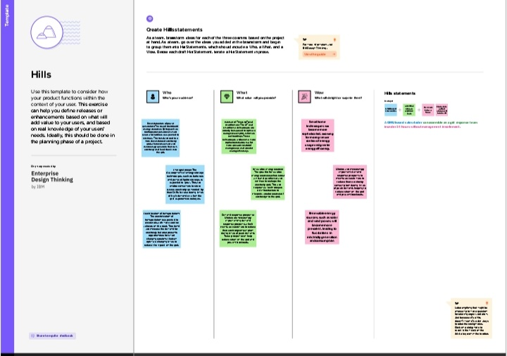

**2.2 Ideation and Brainstorming Map**

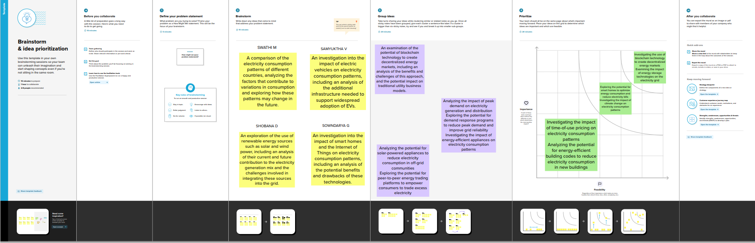

**RESULT**

**Screenshots of output:**

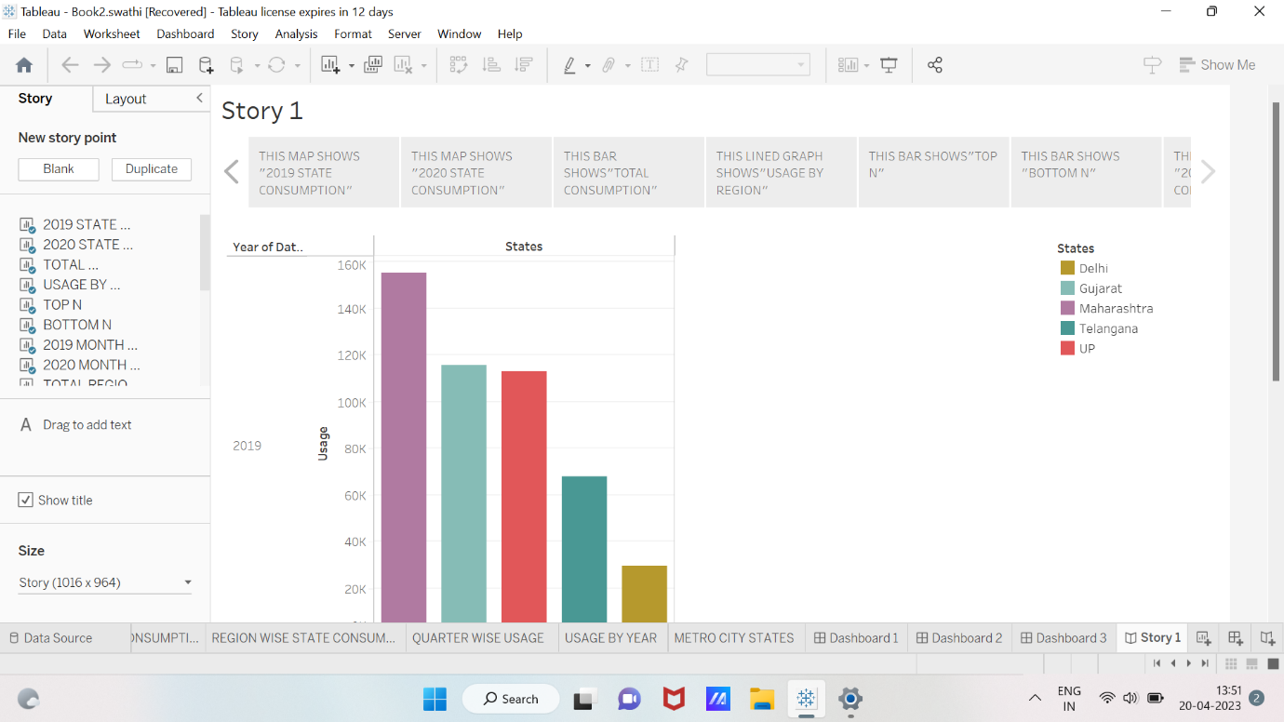

**Fig3.1 Story webpage**

**Fig 3.2 Dashboard webpage**

**Fig 3.3 Dashboard webpage**

**Fig 3.4 Dashboard webpage**

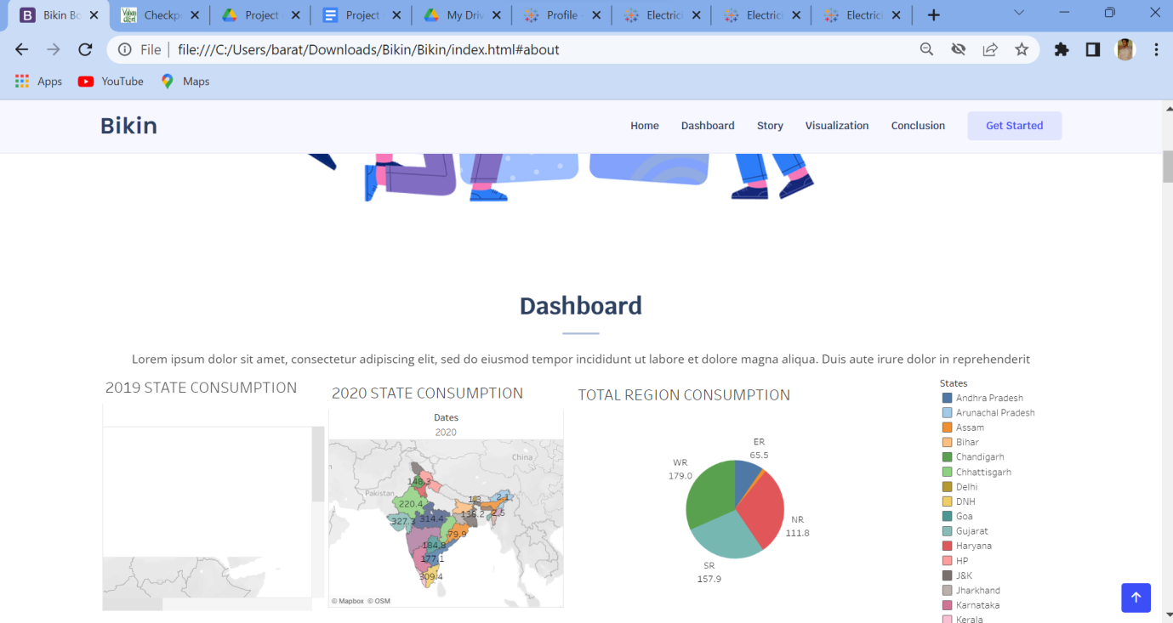**Fig 3.5 Webpage of the project**

**ADVANTAGES & DISADVANTAGES**

**ADVANTAGES:**

**1.Promoting sustainable energy use:**

One of the primary advantages of the study is that it can help promote sustainable energy use. By understanding the various factors that influence electricity consumption patterns and identifying ways to optimize energy consumption for efficiency and sustainability, the study can help individuals, organizations, and governments adopt energy-efficient practices and invest in sustainable technologies.

**2.Reducing environmental impact:**

Another significant advantage of the study is that it can help reduce environmental impact. Electricity consumption is a significant contributor to greenhouse gas emissions, which can lead to climate change and other environmental issues. By promoting sustainable energy use and reducing reliance on fossil fuels, the study can help reduce environmental impact and contribute to a cleaner, healthier planet.

**3.Improving energy efficiency:**

The study can also help improve energy efficiency. Energy efficiency is essential for reducing energy waste, lowering energy costs, and promoting sustainability. By identifying ways to optimize energy consumption patterns and leveraging technology and policies to promote energy efficiency, the study can help improve overall energy efficiency and reduce energy consumption.

**4.Informing decision-making:**

The study can also provide valuable insights that can inform decision-making at the individual, organizational, and governmental levels. By understanding the various factors that influence electricity consumption patterns and evaluating the effectiveness of different interventions and policies, stakeholders can make informed

**DISADVANTAGES:**

**1.Cost:**

Conducting a comprehensive study of electricity consumption patterns can be expensive, particularly if it involves collecting and analyzing large amounts of data. This cost may be a barrier to conducting the study or implementing its recommendations.

**2.Data privacy concerns:**

Collecting and analyzing data on individual electricity consumption patterns may raise privacy concerns, particularly if the data is being collected without individuals' consent or knowledge. Ensuring that data collection and analysis is conducted in a responsible and ethical manner is crucial to addressing these concerns.

**3.Limited scope:**

Depending on the focus and scope of the study, it may not address all of the factors that influence electricity consumption patterns or provide a complete picture of energy use. This may limit the effectiveness of the study's recommendations and its ability to address broader energy and sustainability issues.

**4.Political and institutional barriers:**

Even if the study provides valuable insights and recommendations, political and institutional barriers may prevent its adoption or implementation. For example, policymakers may be hesitant to implement certain recommendations due to political pressure or conflicting interests.

**5.Limited generalizability:**

The study's findings may not be generalizable to other contexts or populations. This may limit its usefulness for informing policy and decision-making beyond the specific population or geographic area studied.

**APPLICATIONS**

**1.Promoting sustainable energy use:**

One of the primary applications of the study is to promote sustainable energy use. The study can provide insights into the factors that influence electricity consumption patterns and identify ways to optimize energy consumption for efficiency and sustainability. By promoting sustainable energy use, individuals, organizations, and governments can reduce their reliance on fossil fuels, lower greenhouse gas emissions, and contribute to a cleaner, healthier planet.

**2.Developing energy-efficient technologies:**

The study can also inform the development of energy-efficient technologies. By identifying emerging trends and evaluating the effectiveness of different technologies and interventions, the study can support the development of innovative solutions for improving energy efficiency. These solutions can range from new energy-efficient appliances to renewable energy technologies such as solar and wind power.

**3.Informing policy and decision-making:**

The study can provide valuable insights and recommendations that can inform policy and decision-making at the individual, organizational, and governmental levels. Policymakers can use the study's findings to develop policies and programs that promote sustainable energy use, reduce environmental impact, and improve energy efficiency. For example, policies such as tax incentives for energy-efficient technologies on energy consumption can be implemented based on the study's recommendations.

**4.Encouraging behavioral change:**

The study can also encourage behavioral change by raising awareness of energy consumption patterns and their impact on the environment. By promoting sustainable habits and behaviors, individuals and organizations can reduce their energy consumption and contribute to a more sustainable future. For example, the study can recommend simple changes such as turning off lights when not in use or adjusting thermostats to save energy.

**5.Supporting research and development:**

The study can also support research and development in the energy sector. By identifying gaps in knowledge and recommending areas for further study, the study can support the development of new technologies, policies, and interventions that promote sustainable energy use, reduce environmental impact, and improve energy efficiency.

In summary, the content of **"Plugging into the Future: An Exploration of Electricity Consumption Patterns"** has several practical applications, ranging from promoting sustainable energy use and developing energy-efficient technologies to informing policy and decision-making, encouraging behavioral change, and supporting research and development. These applications can help create a more sustainable future by reducing environmental impact, promoting energy efficiency, and encouraging the adoption of sustainable practices and technologies.

**CONCLUSION**

In conclusion, **"Plugging into the Future: An Exploration of Electricity Consumption Patterns"** is a valuable study that can help promote sustainable energy use, reduce environmental impact, and improve energy efficiency. The study's findings and recommendations have several applications, including informing policy and decision-making, encouraging behavioral change, supporting research and development, promoting sustainable energy use, and developing energy-efficient technologies. By addressing the factors that influence electricity consumption patterns and identifying ways to optimize energy consumption for efficiency and sustainability, the study can help create a more sustainable future.

However, there are also potential disadvantages to consider, such as cost, data privacy concerns, limited scope, political and institutional barriers, and limited generalizability. These factors should be carefully evaluated and addressed to ensure that the study's findings are useful, actionable, and socially responsible.

Overall, **"Plugging into the Future: An Exploration of Electricity Consumption Patterns"** highlights the importance of understanding and optimizing energy consumption patterns for sustainability and environmental protection. By promoting sustainable energy use and encouraging the adoption of energy-efficient technologies and practices, we can create a cleaner, healthier planet for ourselves and future generations.

**FUTURE SCOPE**

The study **"Plugging into the Future: An Exploration of Electricity Consumption Patterns"** has significant future scope and potential for further research and development. Here are some of the potential future directions for this study:

**1.Expanding the study's scope:**

While the study provides valuable insights into electricity consumption patterns, it is limited to a specific geographic area and time period. Future research could expand the study's scope to include a larger sample size or different regions and time periods to identify broader trends and patterns.

**2.Incorporating new technologies:**

As new technologies emerge, there is a need to evaluate their impact on electricity consumption patterns. Future research could incorporate emerging technologies such as electric vehicles, smart homes, and energy storage systems to better understand their impact on energy consumption.

**3.Integrating machine learning and artificial intelligence:**

Machine learning and artificial intelligence can help analyze large datasets and identify patterns that may not be apparent through traditional statistical methods. Future research could integrate these technologies to improve the accuracy and efficiency of analyzing electricity consumption patterns.

**4.Assessing the impact of policy interventions:**

Policies and programs aimed at promoting sustainable energy use can have a significant impact on electricity consumption patterns. Future research could evaluate the effectiveness of these policies and identify areas for improvement.

**5.Addressing social and cultural factors:**

Social and cultural factors can play a significant role in shaping energy consumption patterns. Future research could incorporate social and cultural factors to better understand how they impact electricity consumption and identify ways to promote sustainable energy use.

**6.Developing innovative solutions:**

The study can inform the development of innovative solutions for promoting sustainable energy use and improving energy efficiency. Future research could focus on developing new technologies, policies, and interventions based on the study's findings and recommendations.

Overall, the study **"Plugging into the Future: An Exploration of Electricity Consumption Patterns"** has significant future scope and potential for further research and development. By expanding the study's scope, incorporating new technologies, integrating machine learning and artificial intelligence, assessing the impact of policy interventions, addressing social and cultural factors, and developing innovative solutions, we can promote sustainable energy use, reduce environmental impact, and create a cleaner, healthier planet.

**APPENDIX**

**SOURCE CODE:**

<!DOCTYPE html>

<html lang="en">

<head>

  <meta charset="utf-8">

  <meta content="width=device-width, initial-scale=1.0" name="viewport">

  <title>Plugging into the Future: An Exploration of Electricity Consumption Patterns</title>

  <meta content="" name="description">

  <meta content="" name="keywords">

  <!-- Favicons -->

  <link href="assets/img/favicon.png" rel="icon">

  <link href="assets/img/apple-touch-icon.png" rel="apple-touch-icon">

  <!-- Google Fonts -->

  <link href="https://fonts.googleapis.com/css?family=Open+Sans:300,300i,400,400i,600,600i,700,700i|Krub:300,300i,400,400i,500,500i,600,600i,700,700i|Poppins:300,300i,400,400i,500,500i,600,600i,700,700i" rel="stylesheet">

  <!-- Vendor CSS Files -->

  <link href="assets/vendor/aos/aos.css" rel="stylesheet">

  <link href="assets/vendor/bootstrap/css/bootstrap.min.css" rel="stylesheet">

  <link href="assets/vendor/bootstrap-icons/bootstrap-icons.css" rel="stylesheet">

  <link href="assets/vendor/boxicons/css/boxicons.min.css" rel="stylesheet">

  <link href="assets/vendor/glightbox/css/glightbox.min.css" rel="stylesheet">

  <link href="assets/vendor/swiper/swiper-bundle.min.css" rel="stylesheet">

  <!-- Template Main CSS File -->

  <link href="assets/css/style.css" rel="stylesheet">

  <!-- =======================================================

  * Template Name: Bikin

  * Updated: Mar 10 2023 with Bootstrap v5.2.3

  * Template URL: https://bootstrapmade.com/bikin-free-simple-landing-page-template/

  * Author: BootstrapMade.com

  * License: https://bootstrapmade.com/license/

  ======================================================== -->

</head>

<body>

  <!-- ======= Header ======= -->

  <header id="header" class="fixed-top">

    <div class="container d-flex align-items-center justify-content-between">

      <h1 class="logo"><a href="index.html">Electricity</a></h1>

      <!-- Uncomment below if you prefer to use an image logo -->

      <!-- <a href="index.html" class="logo"><img src="assets/img/logo.png" alt="" class="img-fluid"></a>-->

      <nav id="navbar" class="navbar">

        <ul>

          <li><a class="nav-link scrollto active" href="#hero">Home</a></li>

          <li><a class="nav-link scrollto" href="#Dashboard">Dashboard</a></li>

          <li><a class="nav-link scrollto" href="#services">Story</a></li>

          <li><a class="nav-link scrollto " href="#portfolio">Visualization</a></li>

          <li><a class="nav-link scrollto" href="#Conclusion">Conclusion</a></li>

          <li><a class="getstarted scrollto" href="#about">Get Started</a></li>

        </ul>

        <i class="bi bi-list mobile-nav-toggle"></i>

      </nav><!-- .navbar -->

 </div>

  </header><!-- End Header -->

  <!-- ======= Hero Section ======= -->

  <section id="hero" class="d-flex align-items-center">

    <div class="container d-flex flex-column align-items-center justify-content-center" data-aos="fade-up">

      <h1>Plugging into the Future: An Exploration of Electricity Consumption Patterns</h1>

      <a href="#about" class="btn-get-started scrollto">Get Started</a>

      <img src="assets/img/hero-img.png" class="img-fluid hero-img" alt="" data-aos="zoom-in" data-aos-delay="150">

    </div>

  </section><!-- End Hero -->

  <main id="main">

   prehenderit</p> <!-- ======= Services Section ======= -->

    <section id="Dashboard" class="Dashboard">

      <div class="container" data-aos="fade-up">

        <div class="section-title">

          <h2>Dashboard</h2>

        <div>

                <div>

                    <div class='tableauPlaceholder' id='viz1681121637300' style='position: relative'><noscript><a href='#'><img alt=' ' src='https:&#47;&#47;public.tableau.com&#47;static&#47;images&#47;El&#47;Electricityconsumption_16810358763820&#47;Dashboard1&#47;1_rss.png' style='border: none' /></a></noscript><object class='tableauViz'  style='display:none;'><param name='host_url' value='https%3A%2F%2Fpublic.tableau.com%2F' /> <param name='embed_code_version' value='3' /> <param name='path' value='views&#47;Electricityconsumption_16810358763820&#47;Dashboard1?:language=en-US&amp;:embed=true' /> <param name='toolbar' value='yes' /><param name='static_image' value='https:&#47;&#47;public.tableau.com&#47;static&#47;images&#47;El&#47;Electricityconsumption_16810358763820&#47;Dashboard1&#47;1.png' /> <param name='animate_transition' value='yes' /><param name='display_static_image' value='yes' /><param name='display_spinner' value='yes' /><param name='display_overlay' value='yes' /><param name='display_count' value='yes' /><param name='language' value='en-US' /></object></div>                <script type='text/javascript'>                    var divElement = document.getElementById('viz1681121637300');                    var vizElement = divElement.getElementsByTagName('object')[0];                    if ( divElement.offsetWidth > 800 ) { vizElement.style.width='100%';vizElement.style.height=(divElement.offsetWidth*0.75)+'px';} else if ( divElement.offsetWidth > 500 ) { vizElement.style.width='100%';vizElement.style.height=(divElement.offsetWidth*0.75)+'px';} else { vizElement.style.width='100%';vizElement.style.height='1527px';}                     var scriptElement = document.createElement('script');                    scriptElement.src = 'https://public.tableau.com/javascripts/api/viz_v1.js';                    vizElement.parentNode.insertBefore(scriptElement, vizElement);                </script>

   </div>

      </div>

    </section><!-- End About Section -->

    <!-- ======= Services Section ======= -->

    <section id="services" class="services">

      <div class="container" data-aos="fade-up">

        <div class="section-title">

          <h2>Story</h2>

        <div>

            <div class='tableauPlaceholder' id='viz1681973899406' style='position: relative'><noscript><a href='#'><img alt='Story 1 ' src='https:&#47;&#47;public.tableau.com&#47;static&#47;images&#47;st&#47;story1swathi&#47;Story1&#47;1_rss.png' style='border: none' /></a></noscript><object class='tableauViz'  style='display:none;'><param name='host_url' value='https%3A%2F%2Fpublic.tableau.com%2F' /> <param name='embed_code_version' value='3' /> <param name='site_root' value='' /><param name='name' value='story1swathi&#47;Story1' /><param name='tabs' value='no' /><param name='toolbar' value='yes' /><param name='static_image' value='https:&#47;&#47;public.tableau.com&#47;static&#47;images&#47;st&#47;story1swathi&#47;Story1&#47;1.png' /> <param name='animate_transition' value='yes' /><param name='display_static_image' value='yes' /><param name='display_spinner' value='yes' /><param name='display_overlay' value='yes' /><param name='display_count' value='yes' /><param name='language' value='en-US' /></object></div>                <script type='text/javascript'>                    var divElement = document.getElementById('viz1681973899406');                    var vizElement = divElement.getElementsByTagName('object')[0];                    vizElement.style.width='1016px';vizElement.style.height='991px';                    var scriptElement = document.createElement('script');                    scriptElement.src = 'https://public.tableau.com/javascripts/api/viz_v1.js';                    vizElement.parentNode.insertBefore(scriptElement, vizElement);                </script>

    </div>

    </section><!-- End Services Section -->

    <!-- ======= Portfolio Section ======= -->

    <section id="portfolio" class="portfolio">

      <div class="container" data-aos="fade-up">

        <div class="section-title">

          <h2>Visualization</h2>

        </div>

        <div class="row portfolio-container">

          <div class="col-lg-4 col-md-6 portfolio-item filter-app">

            <div class="portfolio-wrap">

              <img src="assets/img/portfolio/Sheet 1.jpg" class="img-fluid" alt="">

              <div class="portfolio-info">

                <h4>App 1</h4>

                <p>App</p>

                <div class="portfolio-links">

                  <a href="assets/img/portfolio/Sheet 1" data-gallery="portfolioGallery" class="portfolio-lightbox" title="App 1"><i> class="bx bx-plus"></i></a>

                  <a href="portfolio-details.html" title="More Details"><i class="bx bx-link"></i></a>

                </div>

              </div>

            </div>

          </div>

          <div class="col-lg-4 col-md-6 portfolio-item filter-web">

            <div class="portfolio-wrap">

              <img src="assets/img/portfolio/Sheet 2.jpg" class="img-fluid" alt="">

              <div class="portfolio-info">

                <h4>Web 3</h4>

                <p>Web</p>

                <div class="portfolio-links">

                  <a href="assets/img/portfolio/Sheet 2.jpg" data-gallery="portfolioGallery" class="portfolio-lightbox" title="Web 3"><i class="bx bx-plus"></i></a>

                  <a href="portfolio-details.html" title="More Details"><i class="bx bx-link"></i></a>

                </div>

              </div>

            </div>

          </div>

  <div class="col-lg-4 col-md-6 portfolio-item filter-app">

            <div class="portfolio-wrap">

              <img src="assets/img/portfolio/Sheet 3.jpg" class="img-fluid" alt="">

              <div class="portfolio-info">

                <h4>App 2</h4>

                <p>App</p>

                <div class="portfolio-links">

                  <a href="assets/img/portfolio/Sheet 3.jpg" data-gallery="portfolioGallery" class="portfolio-lightbox" title="App 2"><i class="bx bx-plus"></i></a>

                  <a href="portfolio-details.html" title="More Details"><i class="bx bx-link"></i></a>

                </div>

              </div>

            </div>

          </div>

          <div class="col-lg-4 col-md-6 portfolio-item filter-card">

            <div class="portfolio-wrap">

              <img src="assets/img/portfolio/Sheet 4.jpg" class="img-fluid" alt="">

              <div class="portfolio-info">

                <h4>Card 2</h4>

                <p>Card</p>

                <div class="portfolio-links">

                  <a href="assets/img/portfolio/Sheet 4.jpg" data-gallery="portfolioGallery" class="portfolio-lightbox" title="Card 2"><i class="bx bx-plus"></i></a>

                  <a href="portfolio-details.html" title="More Details"><i class="bx bx-link"></i></a>

                </div>

              </div>

            </div>

          </div>

          <div class="col-lg-4 col-md-6 portfolio-item filter-web">

            <div class="portfolio-wrap">

              <img src="assets/img/portfolio/Sheet 5.jpg" class="img-fluid" alt="">

              <div class="portfolio-info">

                <h4>Web 2</h4>

                <p>Web</p>

                <div class="portfolio-links">

                  <a href="assets/img/portfolio/Sheet 5.jpg" data-gallery="portfolioGallery" class="portfolio-lightbox" title="Web 2"><i class="bx bx-plus"></i></a>

                  <a href="portfolio-details.html" title="More Details"><i class="bx bx-link"></i></a>

                </div>

              </div>

            </div>

          </div>

 <div class="col-lg-4 col-md-6 portfolio-item filter-app">

            <div class="portfolio-wrap">

              <img src="assets/img/portfolio/Sheet 6.jpg" class="img-fluid" alt="">

              <div class="portfolio-info">

                <h4>App 3</h4>

                <p>App</p>

                <div class="portfolio-links">

                  <a href="assets/img/portfolio/Sheet 6.jpg" data-gallery="portfolioGallery" class="portfolio-lightbox" title="App 3"><i class="bx bx-plus"></i></a>

                  <a href="portfolio-details.html" title="More Details"><i class="bx bx-link"></i></a>

                </div>

              </div>

            </div>

          </div>

          <div class="col-lg-4 col-md-6 portfolio-item filter-card">

            <div class="portfolio-wrap">

              <img src="assets/img/portfolio/Sheet 7.jpg" class="img-fluid" alt="">

              <div class="portfolio-info">

                <h4>Card 1</h4>

                <p>Card</p>

                <div class="portfolio-links">

                  <a href="assets/img/portfolio/Sheet 7.jpg" data-gallery="portfolioGallery" class="portfolio-lightbox" title="Card 1"><i class="bx bx-plus"></i></a>

                  <a href="portfolio-details.html" title="More Details"><i class="bx bx-link"></i></a>

                </div>

              </div>

            </div>

          </div>

          <div class="col-lg-4 col-md-6 portfolio-item filter-card">

            <div class="portfolio-wrap">

              <img src="assets/img/portfolio/Sheet 8.jpg" class="img-fluid" alt="">

              <div class="portfolio-info">

                <h4>Card 3</h4>

                <p>Card</p>

                <div class="portfolio-links">

                  <a href="assets/img/portfolio/Sheet 8.jpg" data-gallery="portfolioGallery" class="portfolio-lightbox" title="Card 3"><i class="bx bx-plus"></i></a>

                  <a href="portfolio-details.html" title="More Details"><i class="bx bx-link"></i></a>

                </div>

              </div>

            </div>

          </div>

          <div class="col-lg-4 col-md-6 portfolio-item filter-web">

            <div class="portfolio-wrap">

              <img src="assets/img/portfolio/Sheet 9.jpg" class="img-fluid" alt="">

              <div class="portfolio-info">

                <h4>Web 3</h4>

                <p>Web</p>

                <div class="portfolio-links">

                  <a href="assets/img/portfolio/Sheet 9.jpg" data-gallery="portfolioGallery" class="portfolio-lightbox" title="Web 3"><i class="bx bx-plus"></i></a>

                  <a href="portfolio-details.html" title="More Details"><i class="bx bx-link"></i></a>

                </div>

              </div>

            </div>

          </div>

        </div>

      </div>

    </section><!-- End Portfolio Section -->

    <!-- ======= Features Section ======= -->

    <section id="Conclusion" class="Conclusion" data-aos="fade-up">

      <div class="container">

        <div class="section-title">

          <h2>Conclusion</h2>

        </div>

        <div class="row content">

          <div class="col-md-5" data-aos="fade-right" data-aos-delay="100">

            <img src="assets/Conclusion/Sheet 10.jpg" class="img-fluid" alt="">

          </div>

          <div class="col-md-7 pt-4" data-aos="fade-left" data-aos-delay="100">

            <h3>Electricity consumption in Stats</h3>

            <ul>

              <li><i class="bi bi-check"></i> Maharastra is the Highest electricity consumption user of India.</li>

              <li><i class="bi bi-check"></i>Gujarat is the Second Highest Electricity consumption.</li>

              <li><i class="bi bi-check"></i>Sikkim is the lowest electricity consumption user of india.</li>

            </ul>

</div>

        </div>

        <div class="row content">

          <div class="col-md-5 order-1 order-md-2" data-aos="fade-left">

            <img src="assets/Conclusion/Sheet 6.jpg" class="img-fluid" alt="">

          </div>

          <div class="col-md-7 pt-5 order-2 order-md-1" data-aos="fade-right">

            <h3>Electricity consumption in Quarters</h3>

            <ul>

              <li><i class="bi bi-check"></i>Electricity consumption in 2019 for Quarter 3 was Highest.</li>

              <li><i class="bi bi-check"></i>Electricity consumption in 2019 for Quarter 1 was Highest.</li>

              <li><i class="bi bi-check"></i>Electricity consumption in 2020 for Quarter 3 was Lowest.</li>

              <li><i class="bi bi-check"></i>Electricity consumption in 2020 for Quarter 1 was Highest.</li>

            </ul>

          </div>

        </div>

        <div class="row content">

          <div class="col-md-5" data-aos="fade-right">

            <img src="assets/Conclusion/Sheet 11.jpg" class="img-fluid" alt="">

          </div>

          <div class="col-md-7 pt-5" data-aos="fade-left">

            <h3>Electricity Consumption in Regions</h3>

            <ul>

              <li><i class="bi bi-check"></i> Total Electricity consumption in Western Region.</li>

              <li><i class="bi bi-check"></i> Total Electricity consumption in North Eastern Region is Lowest.</li>

              <li><i class="bi bi-check"></i> Electricity Consumption in 2020 for Quarter 3 was Lowest.</li>

            </ul>

          </div>

        </div>

        </div>

      </div>

    </section><!-- End Features Section -->

</footer><!-- End Footer -->

  <div id="preloader"></div>

  <a href="#" class="back-to-top d-flex align-items-center justify-content-center"><i class="bi bi-arrow-up-short"></i></a>

  <!-- Vendor JS Files -->

  <script src="assets/vendor/aos/aos.js"></script>

  <script src="assets/vendor/bootstrap/js/bootstrap.bundle.min.js"></script>

  <script src="assets/vendor/glightbox/js/glightbox.min.js"></script>

  <script src="assets/vendor/isotope-layout/isotope.pkgd.min.js"></script>

  <script src="assets/vendor/swiper/swiper-bundle.min.js"></script>

  <script src="assets/vendor/php-email-form/validate.js"></script>

  <!-- Template Main JS File -->

  <script src="assets/js/main.js"></script>

</body>

</html>